# Website Proposal: LEGO Set and Piece Cataloging | Overview | Phil Kershner, Ryan Farley, Aidan Elm

We are going to design a user-friendly website for cataloging LEGO sets and pieces. The users will be able to view LEGO sets, observe single pieces, and set up their personal LEGO collections on their own. A user should be allowed to create a customized set by choosing pieces - this will be added to the database. Saving and managing one's collection will be supported via a well-organized interface.

# Expected Functionalities

1. **User Registration and Login:** Users create an account and log in with the account for personalized features.
2. **LEGO Sets Research:** Overview, details, and specifications of a variety of LEGO sets can be viewed and searched.
3. **View Individual Pieces:** View LEGO parts, going into details with images, description, and piece data.
4. **Custom set creation**: Users can pick which pieces make up their unique sets.
   1. INSERT INTO: Users can insert pieces into their custom sets.
   2. DELETE: Users can delete pieces from their custom sets if they are no longer needed.
   3. SELECT: Retrieves and displays stored custom sets for the user.
   4. UPDATE: Modify existing custom sets: add or remove pieces.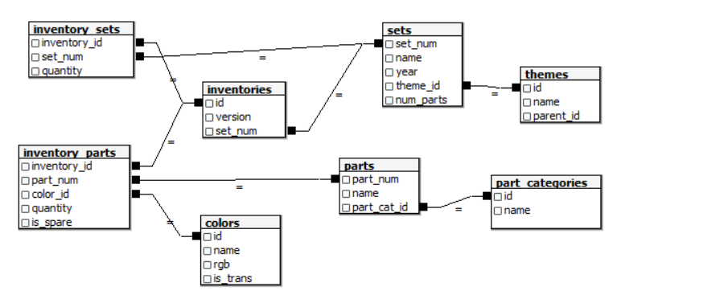

# Dataset Sources

* LEGO Database: [Kaggle LEGO Database](https://www.kaggle.com/datasets/rtatman/lego-database)
* LEGO Sets: [Kaggle LEGO Sets](https://www.kaggle.com/datasets/mterzolo/lego-sets)

# Design Resources

* **Color Scheme:** [LEGO Brand Colors](https://www.brandcolorcode.com/lego)
* **CSS Framework:** [Bootstrap](https://getbootstrap.com/)
* **Inspiration:** [CodePen Example 1](https://codepen.io/abdel4/pen/gOyKjRz) | [CodePen Example 2](https://codepen.io/laszlobarath/pen/qBzKNjd) | [CodePen Example 3](https://codepen.io/IncurableHam/pen/YRrVRG)

# Architecture

The user will interact with the site through a browser displaying elements from the Bootstrap framework. On the backend, a Node.js server running the web application will interact with a MySQL server to get the LEGO data. The project files and a report will be entered into the “FinalProject” GitHub repository.